FIRM 17 - CLASS C
KENYA SCHOOL OF LAW
ADVOACATES TRAINING PROGRAMME
ATP 107: CONVEYANCING LAW
2024/2025 ACADEMIC YEAR

TASK: FIRM 17
1. Draw/sample of a notice of proposed allocation of public land.
2. Draw/sample of an auctioneer’s certificate of sale upon auction of public land.
3. Draw/sample of a notice inviting bids for allocation of public land.

FIRM MEMBERS:
- Martin Munyoto
- Cherono Mercy
- Manthi Samuel
- Marion Onchagwa
- Saina George
- Abio Jordan
- Korir Hope
- Gladys Kabira
- Faith Mukuma

THE LAND (ALLOCATION OFPUBLIC LAND) REGULATIONS, 2017
Introduction
Pursuant to section 12 (I) of the Act, the National Land Commission shall, on the request of the national or a county government, where necessary, allocate the whole or part of a specific public land by;
- Public auction;
- Application confined to a targeted group of persons or groups;
- Public notice of tenders;
- Public drawing of lots;
- Public request for proposals; and
- Public land exchange of equal value.
In determining the method of allocation, the Commission shall, in consultation with the national government or respective county Government as the case may be, take into consideration all prevailing circumstances including the purpose for the allocation.

a). Sample of a notice of proposed allocation of public land

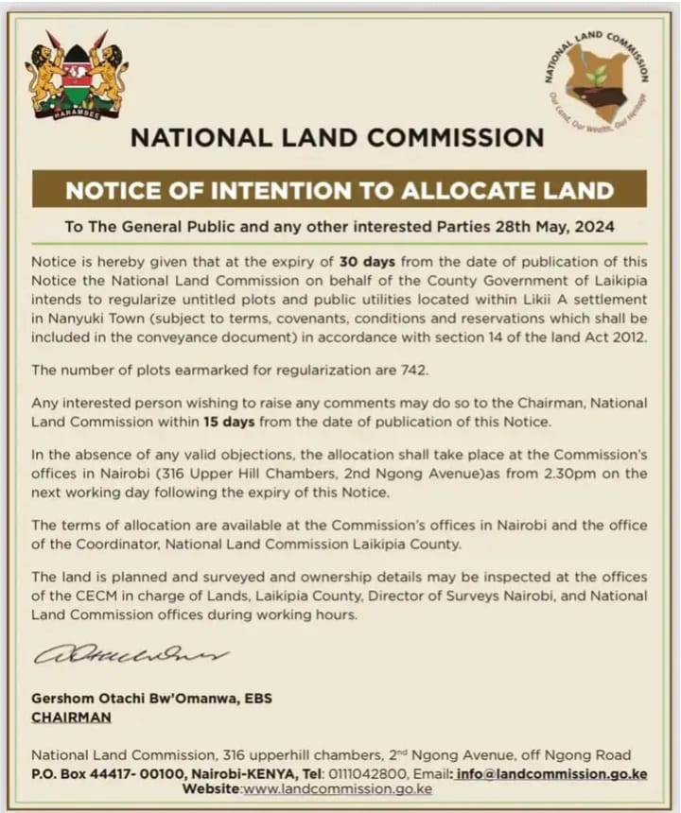

b) AUCTIONEER’S CERTIFICATE OF SALE UPON AUCTION OF PUBLIC LAND
The Commission shall, after giving notice in accordance with section 14 of the Act, appoint a licensed auctioneer, by name, as its agent, for all or each parcel of land available for auction.
The Commission shall publish a notice in at least two daily newspapers of nation-wide circulation, one local newspaper and affix the notice at the county, sub-county and ward offices, specifying; the date of the auction which shall be at least one month from the date of the publication of the notice, the description of the land, the reserve price being the stand premium, the date, time and venue of the auction, the amount to be paid at the fall of the hammer, and the terms and conditions of allocation.
Every auction shall be conducted by an agent appointed under Regulation 4 in the presence of an authorized office of the auction' commission. The agent shall declare as winner the name of the highest bidder if the bid is higher than the reserve price. The winner of the bid shall, at the fall of the hammer, pay to the commission the full amount of the bid or percentage specified in
the notice. The agent shall immediately on the fall of the hammer issue a CERTIFICATE OF SALE in Form LA-4 set out in the Schedule signed by the agent (auctioneer) to the winner of the bid and the commission as evidence of the sale. The winner of the bid shall present the certificate issued to the Commission for issuance of the Letter of Allotment in Form LA-5 set out in the Schedule and pay the outstanding balance within ninety days. The Commission shall ensure that the process under this part complies with the Public Procurement and Asset Disposal Act,2015.

b). Draw/sample of an auctioneer’s Certificate of Sale upon auction of Public Land

FORM LA.4 (r.6(5))

REPUBLIC OF KENYA
NATIONAL LAND COMMISSION
Serial No:11029922
CERTIFICATE OF SALE OF PUBLIC LAND IN A PUBLIC AUCTION

Name: STANELY MOGAKA
Postal Address: P.O. BOX 12625-00200, NAIROBI
ID No./Passport No: 33901121
PIN No: A012016778X

This is to certify that the above-named holder of this form has successfully qualified for allocation of Parcel Reference No. KAJIADO/KAPUTEI NORTH/13001 having participated in the public auction held on 20th day of August 2024 at PANGANI AUCTION CENTER
This form should be presented to the Chairman, National Land Commission within 90 (ninety) days for issuance of Letter of Allotment.

(Signature)
Auctioneer.
CC.
TO: CS, Ministry in charge of Lands
Officer or authority responsible for surveys
Director of Physical Planning
The County Executive Committee Member for Lands
O/C Land Rent
O/C Rates
The Accountant
O/C Records. All to note.
Senior Plan Record Officer

NATIONAL LAND COMMISSION
- ALLOCATION OF PUBLIC LAND BY WAY OF TENDERS
The Commission shall, after giving notice in accordance with section 14 of the Act, invite bids for tenders by publishing a notice in Form LA 6 set out in the Schedule at the county, sub-county and ward offices and in two daily newspapers of nationwide circulation and one local newspaper at least two months before the date of the opening of the bids.
The notice inviting the bids shall, with respect to each tender, specify;
- the sale number;
- bidding information including-
i). the particulars of the parcel or parcels on offer,
ii). The date and time for submission of the bid registration form,
iii). the bid submission closing date and time;
(iv) the bid opening time; and
(v) the reserve price;
c) A schedule of the list of properties with the item number for bidder reference, place and time to inspect land, bidder registration requirement as well as contact person(s) or place(s) and times at which bidders can register and obtain bid forms, and any other specific terms and conditions of sale.
Every bid shall be submitted in a sealed envelope to invite bids. The sealed envelope containing the bid shall be placed in a closed and sealed box provided for that purpose. Bids shall be opened in the presence of the bidders and shall be numbered consecutively. The Commission then select the winning bid and the Commission’s secretary will notify both the successful and unsuccessful bidders. The unsuccessful bidders will be notified of the rejection of their bids in details.
The Commission shall issue a Letter of Allotment in Form LA-5 set out in the Schedule to the successful bidder. The successful bidder pays to the Commission the stand premium within 90 days of receipt of the Commission's letter of notification under Regulation 16(1). The Commission ensures is in compliance with Public Procurement and Asset Disposal Act,

c). Draw/sample of a Notice inviting bids for allocation of public land

FORM LA.6 (r.10)
REPUBLIC OF KENYA
NATIONAL LAND COMMISSION
INVITATION FOR BIDS FOR ALLOCATION OF PUBLIC LAND
The National Land Commission hereby gives notice of intention to allocate the parcel(s) of land described in the schedule hereunder subject to terms available at the Commission’s Office in Nairobi and at the Commission’s Office in KAJIADO County. The mode of allocation shall be by way of Tenders as prescribed under S.12(1) of the Land Act, 2012.
The allocation shall take place at the Commission’s offices in Nairobi (316 Upperhill Chambers, 2nd Ngong Avenue) on Tuesday, 5th October, 2024 at 9.00a.m.
Members of public are hereby invited to apply. Application forms are available at the offices of the Commission at the county level, office of the Cabinet Secretary, Ministry in charge of Lands, Director of Surveys, Director of Physical Planning, the County Executive Committee Member for Lands, O/C Land Rent, O/C Rates, the Accountant, O/C Records or Senior Plan Record Officer or may be downloaded at the Commission’s website www.landcommission.go.ke
Duly completed application forms should be returned to the office of KAJIADO County Land Management Board within 30 (thirty) days from the date hereof with a nonrefundable fee of Kshs 1000/- (one thousand only)
Parcel No: KAPUTEI NORTH/13001 Area Hectares: 20.674 User Fees payable

NATIONAL LAND COMMISSION

